**Data Structures**

Implementation of Min Heap

**Min binary heap:**

* In a min heap the data of the root node must be less than or equal to its children

Nodes data and this property holds for all the nodes of the min binary heap.

* 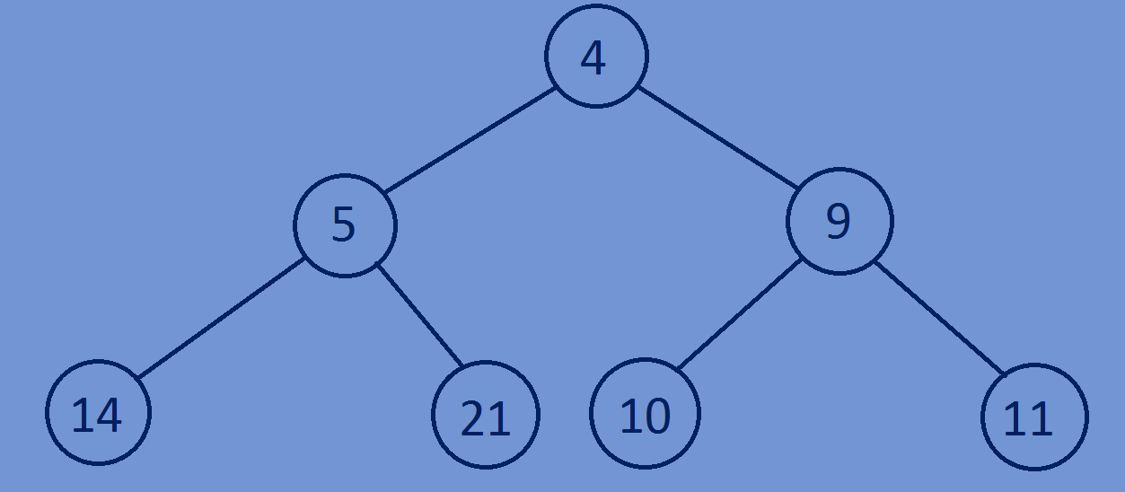In case of min heap the root node will have the smallest element compared to all other Nodes.

**Implementation of Min binary heap:**

* Given a complete binary tree convert the complete binary tree into a min binary heap.
* For a given node, heapify the left subtree,similarly heapify the right subtree

And after that if necessary bubble down the current node such that the tree

Rooted with the current node satisfies min heap property.

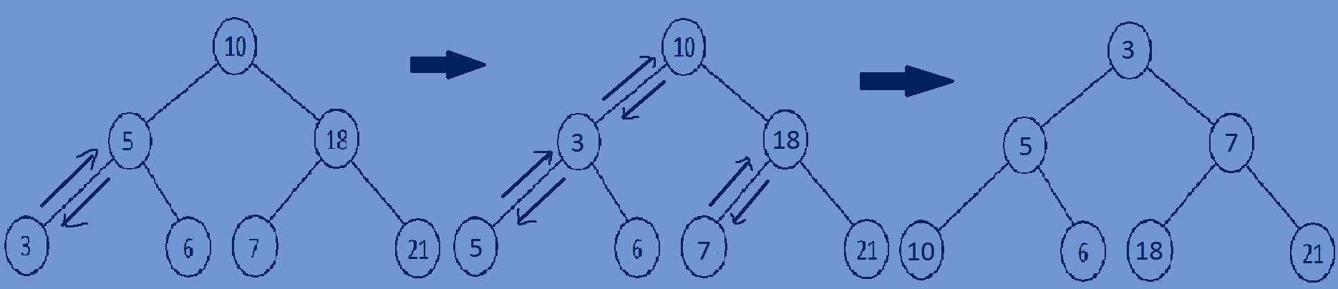

**Implementation of Min binary heap using a complete binary tree:**

* First traverse through each node of a complete binary tree in preorder fashion and while traversing compare the Data in the left child of the node with data of the node and if data in left child is less than data in the parent node then swap the Data and again call the recursive function with left subtree,if the data in right

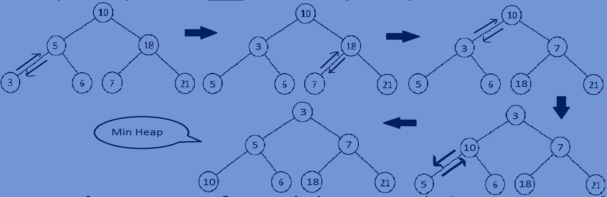Child is less than data in the parent node swap the data and again call the recursive function with the right subtree.

**Function for heapifying a complete binary tree:**

//function for heapifying of a complete binary tree  
**void** heapify(Bstree *root){  
 **if** (root == NULL) {  
 **return**;  
 }  
 heapify(root->left);  
 heapify(root->right);  
 BubbleDown(root);  
}  
//recursive function for bubbling the nodes based on comparison.  
**void** BubbleDown(Bstree *node){  
 Bstree *smallestNode;  
 **if**(node==NULL){  
 **return**;  
 }  
 **if**(node->left!=NULL && node->left->data < node->data){  
 smallestNode=node->left;  
 swapData(node,smallestNode);  
 BubbleDown(smallestNode);  
 }  
 **if**(node->right!=NULL && node->right->data < node->data){  
 smallestNode=node->right;  
 swapData(node,smallestNode);  
 BubbleDown(smallestNode);  
 }  
}  
//swaping data of two nodes  
**void** swapData(Bstree *temp1,Bstree *temp2){  
 **int** temp3;  
 temp3=temp1->data;  
 temp1->data=temp2->data;  
 temp2->data=temp3;  
}

**Whole program:**

#include<stdio.h>  
#include<stdlib.h>  
//creating a node  
**typedef struct** Bstree{  
 **int** data;  
 **struct** Bstree *left;  
 **struct** Bstree *right;  
}Bstree;  
//creating new nodes  
Bstree *createnewnode(**int** data){  
 Bstree *newnode=(Bstree*)malloc(**sizeof**(Bstree));  
 newnode->data=data;  
 newnode->left=NULL;  
 newnode->right=NULL;  
 **return** newnode;  
}

//swaping data of two nodes  
**void** swapData(Bstree *temp1,Bstree *temp2){  
 **int** temp3;  
 temp3=temp1->data;  
 temp1->data=temp2->data;  
 temp2->data=temp3;  
}

//recursive function for bubbling the nodes based on comparison.  
**void** BubbleDown(Bstree *node){  
 Bstree *smallestNode;  
 **if**(node==NULL){  
 **return**;  
 }  
 **if**(node->left!=NULL && node->left->data < node->data){  
 smallestNode=node->left;  
 swapData(node,smallestNode);  
 BubbleDown(smallestNode);  
 }  
 **if**(node->right!=NULL && node->right->data < node->data){  
 smallestNode=node->right;  
 swapData(node,smallestNode);  
 BubbleDown(smallestNode);  
 }  
}  
//function for heapifying of a complete binary tree  
**void** heapify(Bstree *root){  
 **if** (root == NULL) {  
 **return**;  
 }  
 heapify(root->left);  
 heapify(root->right);  
 BubbleDown(root);  
}  
//print all the nodes of a tree in preorder fashion  
**void** preorder(Bstree *root){  
 **if**(root){  
 printf("%d ",root->data);  
 preorder(root->left);  
 preorder(root->right);  
 }  
}  
//main function  
**int** main(){  
 Bstree *tree=NULL;  
 tree=createnewnode(8);  
 tree->left=createnewnode(10);  
 tree->right=createnewnode(9);  
 tree->left->left=createnewnode(2);  
 tree->left->right=createnewnode(7);  
 tree->right->left=createnewnode(1);  
 tree->right->right=createnewnode(2);  
 preorder(tree);printf("\n");  
 heapify(tree);  
 preorder(tree);  
 **return** 0;  
}

**Output:**

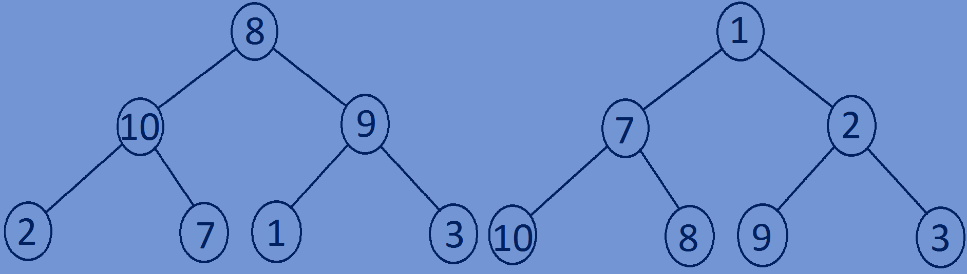8 10 2 7 9 1 3

1 7 10 8 2 9 3